**SYNOPSIS**

**NURTURE HEALTH**

A Doctor Patient Website

Submitted in partial fulfillment of the

requirements for the award of

**Degree of Bachelor of Technology in Computer Science Engineering**

**Batch: 2016-2020**



**SUBMITTED BY:**

Nikita Rajpoot

1601003344

CSE-B

**SUBMITTED TO:**

**Department of Computer Science & Engineering**

**RAYAT BAHRA UNIVERSITY, KHARAR, MOHALI**

**TABLE OF CONTENTS**

**Sr. No Name of the Chapters Page No**

**Chapter 1 Company Profile…………….…………………………1**

1.1 Foundation………………………………………………1

1.2 Services………………………………………………….2

**Chapter 2 Introduction of the project………….…………….…...3**

2.1 Introduction……………………………………………...3

2.2 Benefits of the project…………………………………...4

2.3 Features of the project…………………………………...4

2.4 Modules of the project…………………………………...4

**Chapter 3 Technology Used…………………….………….….…...6**

3.1 About Python…………………………………………….6

3.2 Front End………………………………………………...6

3.3 Back End…………………………………………………7

**Chapter 4 Platforms/Tools Used…………….………………........10**

4.1 Hardware Platform……………………………………...10

4.2 Software Platform……………………………………….10

**Chapter 5 Feasibility Study…………………….……………….....11**

5.1 Technical Feasibility…………………………………….11

5.2 Operational Feasibility…………………………………..11

5.3 Behavioral Feasibility…………………………………...11

5.4 DFD Diagrams…………………………………………..12

**Chapter 6 Conclusion and Bibliography……….……….………..16**

6.1 Conclusion and Future Scope……………………………16

6.2 Bibliography…………………………………………….16



**CHAPTER-1**

**COMPANY PROFILE**

**FOUNDATION:**

STS has been founded by group of senior IT Professional. Right from the inception of this start up, STS has prospered by Leaps and bounds in technology products and critical solutions. SachTech Solution established back in 29 December, 2011 at Mohali, India to serve the varying need of individuals as well as SMEs in today’s competitive market across the globe it was incorporated as SACHTECH SOLUTION PRIVATE LIMITED with CIN U72900CH2016PTC041177 on 11th Aug 2016 under the Companies Act, 2013 in India.

As of year 2018, SachTech has a strong team of more than 80 members in Mohali, India lead by passionate young entrepreneurs serving customers from across the globe in following countries: USA, Canada, UK, Brazil, Spain, Malaysia, UAE, Egypt, Australia, Finland and so on. We are continuously increasing our reach with potential customers and determined to expand our services to everyone in the globe. We embrace our responsibility to create a positive impact in the communities in which we work and live. We use proven knowledge to make recommendations and provide expert guidance to our customers. We listen, we care, and we serve. SachTech Solution innovates and constantly improves. We do what we say we’ll do. SachTech Solution believes in people and their dreams.

Within the span of six years, STS is the strong team of more than 80 members having its presence in India (Mohali) in 7000 sq. ft. & in Canada. Our operations are spread in New York, UK, Australia, Saudi Arabia, UAE and Israel.

**Mission & Vision:** Our Mission is to be the world's leading IT Channel in products, services and solutions that empower and alchemize the way consumers and businesses assemble, manage, distribute and communicate information. Our vision is to become a world-class software development and technology provider and to provide clients with innovated technical and business solutions by utilizing industry standards and technology.

**Achievements:** STS believes in Quality and it is evident from various technology breaks through like from fastest development systems to Desktop Retail Applications integrated with highly innovative data center services. STS works along with the client to improve its business outcomes by exploring new business opportunities, deriving cost takeout, and increasing process efficiency without any major change. From innovative ideas to their implementation and thereafter, STS offers all business transformation outsourcing services to clients under one flagship in four different phases of consulting, developing, outsourcing and training.

**SERVICES WE OFFER:**

1. **Consulting**: STS has 360-degree approach including each business process through a panel of various domain experts, who work hard along with the client to identify the requirements to achieve client's goal while respecting its value. STS has devised ready to opt industry vertical consulting solutions for various processes like Business Case Analysis, Business process re-engineering and Management product, Development and Management, IT Strategy Formulation, Technology Support Development, Internal Marketing, Product Testing, Performance Management etc.
2. **Development**: STS has the honor of developing innovative technologies and the growth of cloud, mobile computing and social media have put additional burdens on staff looking to quickly provide modern solutions. We also offer bouquet of various enterprise solutions, Android applications, Desktop applications, Web & Device Applications.
3. **Outsourcing:** Besides various readymade STS business process outsourcing solutions for various processes like collocation services, Onsite Database Administration Services, Online Counter etc., we have specialization in various industrial critical, technical and general processes. Our man resources are trained for client processes and work as client’s integral part and are fully accessible by client directly.
4. **Industrial Training:** From corporate training to end user training and technical Trainings like System Administration, Enterprise Architecture, Enterprise Network etc.

STS has client based dedicated training programs to ensure client can take maximum advantage of our system, services and solutions. Apart from in-house trainers, we have ever-growing team of our training partners offering customized professional training modules to enterprising and up comings professionals.

Bottom of Form

***WEBSITE:*** [**www.sachtechsolution.com**](http://www.sachtechsolution.com)

**CHAPTER-2**

**INTRODUCTION OF THE PROJECT**

A doctor patient Website is a managing system that helps doctors in their work and also patients to book doctor appointments and view medical progress. The system allows doctors to manage their booking slots online.

Patients are allowed to book empty slots online and those slots are reserved in their name. The system manages the appointment data for multiple doctors for various date and times. Each time a user visits a doctor his/her medical entry is stored in the database by doctor. Next time a user logs in he may view his/her entire medical history as and when needed.

At the same time a doctor may view patient’s medical history even bore the patient visits him. This allows for an automated patient doctor handling system through an online interface. Our system also consists of organ donor module. This module allows for organ donation registration as well as organ search. The module is designed to help urgent organ requirements through easy/instant searches.

**BENEFITS:**

* This system helps the patient to get organ quickly whenever required.
* Patient does not have to wait in queue to visit the doctor.
* This system saves time of both doctor and patient.
* Patient can view his medical history whenever required.
* Patient does not have to carry medical prescription whenever he visits the doctor.

**FEATURES:**

* **Provide free web space:** Members of these sites do not need to own or share web servers. They can publish their own content on the free space provided by these sites.
* **Provide free web address:** Members are allotted a unique web address that becomes the web identity of an individual or a business. It can be used to identify, connect and share content.
* **Ask members to build profiles:** These sites require members to build their profiles. Information entered in the profiles is used to connect friend and contacts, and build networks that connect people with similar likes and interests across the world.
* **Direct message facility:** Several social media sites provide direct messaging facility to their members. This allows members to send private messages, which can be read or viewed only by those for whom the message is intended.

**MODULES:**

My project “**DOCTOR PATIENT WEBSITE”** is broken into small modules so that I will complete my project easily and make it effective. I broke/split/divide my project in small 3 different modules as follows:

* **Admin Login:** The system is under supervision of admin who manages the bookings made.
* **User login/registration:** Users have to first register themselves to login into the system.
* **Medical History:** System allows to update and view patient medical history.
* **Doctor Search:** System allows for doctor search through categories, name and location.
* **Appointment availability check:**User can click on spaces to view the availability.
* **Appointment booking online for date and time:**Users can book appointment for their required date and time.
* **Automatic cost calculation:** The system calculates the total cost incurred for parking based on the time that user has asked for booking.
* **Booking cancellation:** User may even cancel their bookings by login into the system anytime.
* **Email on appointment booking:** When user is successful in appointment confirmation and ‘thank you’ email regarding the slot booked.
* **Feedback:** The system has a feedback form, where user can provide feedback into the system.
* **Organ Donor Registration:** User who is going to donate organ has to register himself by filling the details.
* **Organ Donor Search:** User can search donar based on type of organ.

**CHAPTER-3**

**TECHNOLOGY USED**

**ABOUT PYTHON:**

Python is an interpreted, object-oriented, high-level programming language with dynamic semantics. Its high-level built in data structures, combined with dynamic typing and dynamic binding, make it very attractive for Rapid Application Development, as well as for use as a scripting or glue language to connect existing components together. Python's simple, easy to learn syntax emphasizes readability and therefore reduces the cost of program maintenance. Python supports modules and packages, which encourages program modularity and code reuse. The Python interpreter and the extensive standard library are available in source or binary form without charge for all major platforms, and can be freely distributed.

Python was conceived in the late 1980s, and its implementation began in December 1989 by Guido van Rossum at Centrum Wiskunde & Informatica (CWI) in the Netherlands as a successor to the ABC language (itself inspired by SETL) capable of exception handling and interfacing with the Amoeba operating system.

**What can PYTHON do?**

Python is a general purpose programming language. Hence, you can use the programming language for developing both desktop and web applications. Also, you can use Python for developing complex scientific and numeric applications. Python is designed with features to facilitate data analysis and visualization.

In, February 1991, van Rossum published the code (labeled version 0.9.0) to alt. sources. Already present at this stage in development were classes with inheritance, exception handling, functions, and the core datatypes of list, dict, str and so on. Also in this initial release was a module system borrowed from Modula-3; Van Rossum describes the module as "one of Python's major programming units". Python's exception model also resembles Modula-3's, with the addition of an else clause. In 1994 comp.lang.python, the primary discussion forum for Python, was formed, marking a milestone in the growth of Python's user base.

Python reached version 1.0 in January 1994. The major new features included in this release were the functional programming tools lambda, map, filter and reduce. Van Rossum stated that "Python acquired lambda, reduce (), filter () and map (), courtesy of a Lisp hacker who missed them and submitted working patches".

**FRONT END:**

* **HTML:** HTML stands for **H**yper **T**ext **M**arkup **L**anguage.

HTML is the standard markup language for creating Web pages.HTML describes the structure of Web pages.

HTML elements are represented by tags.HTML tags label pieces of content such as "heading", "paragraph", "table", and so on.

Browsers do not display the HTML tags, but use them to render the content of the page.

* **CSS:** CSS stands for **C**ascading **S**tyle **S**heets. It is a simply designed language intended to simplify the process of making web pages presentable.

CSS describes how HTML elements are to be displayed on screen, paper, or in other media. CSS saves a lot of work.

CSS provides powerful control over the presentation of an HTML document. It can control the layout of multiple web pages all at once.

* **BOOTSTRAP:** Bootstrap is a free and open-source framework for faster and easier web development. It’s the most popular HTML, CSS, and JS framework for developing responsive, mobile first projects on the web.

It includes HTML and CSS based design templates for common user interface components like Typography, Forms, Buttons, Tables, Navigations, Dropdowns, Alerts, Modals, Tabs, Accordion, Carousel and many other as well as optional JavaScript extensions.

* **Java Script:** Java Script (JS for short) is a full-fledged dynamic programming language that, when applied to an HTML document, can provide dynamic interactivity on websites. It is very powerful **client-side scripting language.** It was initially created to “make web pages alive”. JavaScript is incredibly versatile. You can start small, with carousels, image galleries, fluctuating layouts, and responses to button clicks. With more experience, you'll be able to create games, animated 2D and 3D graphics, comprehensive database-driven apps, and much more!

**BACK END:**

* **PYTHON:** Python is a general purpose, dynamic, high level and interpreted programming language. It supports Object Oriented programming language. It is simple and easy to learn and provide lots of high-level data structures.

Python is easy to learn yet powerful and versatile scripting language which make it attractive for Web Development.

Python is not intended to work on special area such as web programming. That is why it is known as multipurpose because it can be used with web, enterprise, 3D CAD etc.

Python make the development and debugging fast because there is no compilation step included in python and edit-test-debug cycle is very fast.

* **DJANGO:** Django is an open-source framework for backend web applications based on python. Its main goals are simplicity, flexibility, reliability and scalability.

Django has its own naming system for all functions and components (e.g., HTTP responses are called “views”).

Django provides a dynamic CRUD (create, read, update and delete) interface, configured with admin modules and generated via introspection. CRUD is used to describe the basic database commands, which means the interface facilitates viewing, changing and searching for introduction.

**We use the DJANGO framework because:**

* It is fast and simple.
* It is secure.
* It suits any web application project.
* It is well established.

**Database Access:**

Django attempts to support as many features as possible on all database back-ends. However, not all database back-ends are alike, and we’ve had to make design decisions on which features to support and which assumptions we can make safely.

This file describes some of the features that might be relevant to Django usage. Of course, it is not intended as a replacement for server-specific documentation or reference manuals.

Django in its 'out-of-the-box' state is set up to communicate with SQLite -- a lightweight relational database included with the Python distribution. So by default, Django automatically creates a SQLite database for your project.

In addition to SQLite, Django also has support for other popular databases that include: PostgreSQL, MySQL and Oracle.

**File Access:**

In Windows, for example, a file can be any item manipulated, edited or created by the user/OS. That means files can be images, text documents, executables, and much more. Most files are organized by keeping them in individual folders.

In Python, a file is categorized as either text or binary, and the difference between the two file types is important.

Text files are structured as a sequence of lines, where each line includes a sequence of characters. This is what you know as code or syntax.

Each line is terminated with a special character, called the EOL or End of Line character. There are several types, but the most common is the comma {,} or newline character. It ends the current line and tells the interpreter a new one has begun.

A backslash character can also be used, and it tells the interpreter that the next character – following the slash – should be treated as a new line. This character is useful when you don’t want to start a new line in the text itself but in the code.

A binary file is any type of file that is not a text file. Because of their nature, binary files can only be processed by an application that know or understand the file’s structure. In other words, they must be applications that can read and interpret binary.

**CHAPTER-4**

**PLATFORMS/ TOOLS USED**

1. **Hardware Platform:**

**Processor:** Intel Core x64

**Processor speed:** 2.10 GHz CPU

**RAM:** 4 GB

**Hard disk utilization:** 100 GB

1. **Software Platform:**

**Front End:** HTML, CSS, BOOTSTRAP, JAVASCRIPT

**Back End:** PYTHON, DJANGO

**Application Server:** APACHE Server

**Operation System:** Windows

**CHAPTER-5**

**FEASIBILITY STUDY**

**TECHNICAL FEASIBILITY:**

It is a measure of the practically of a specific technical solution and the availability of technical resources and expertise

* The proposed system uses Bootstrap, CSS, HTML, JavaScript as front-end and Django server as back-end tool.
* Django is a popular tool used to design and develop database objects such as table views, indexes mainly it is a framework with a set of rules.
* The above tools are readily available, easy to work with and widely used for developing commercial application.

Hardware used in this project are i3 processor 2.4GHz, 2GB DDR3 memory, 500 GB hard disk. These hardwares were already available on the existing computer system. The software like Atom Editor, Anaconda IDE and operating system WINDOWS 10 used were already installed on the existing computer system. So no additional hardware and software were required to purchase and it is technically feasible.

**OPERATIONAL FEASIBILITY:**

It is common knowledge that computer installations have something to do with turnover, transfers, retraining and changes in employee job status. Therefore, it is understandable that the introduction of a candidate system requires special efforts to educate, sell, and train the staff on new ways of conducting business.

* No major training and new skills are required as it is based on Django set of rules and regulations.
* It will help in the time saving and fast processing and dispersal of user request and applications.
* New product will provide all the benefits of present system with better performance.
* Improved information, better management and collection of the reports.
* User support.

From there points our project is operationally feasible too.

**BEHAVIORAL FEASIBILITY:**

People are inherent to change. In this type of feasibility check, we come to know if the newly developed system will be taken and accepted by the working force i.e. the people who will use it.

**DATA FLOW DIAGRAMS (DFD):**

DFD’s have the purpose of clarifying system requirements and identifying major transformations that will become programs in system design. A DFD is also known as “Bubble chart” has the purpose of clarifying system requirements and identifying major. Transformations that will become programs in system design. So it’s a starting point of the design phase that functionality decomposes the requirements specifications down lines. The bubbles represent data transformation and lines represent data flows in the system.

**Context Diagrams:**

A context diagram is a top level (also known as Level 0) data flow diagram. It only contains one process node (process 0) that generalizes the function of the entire system in relationship to external entities. The Context Diagram shows the system under consideration as a single high-level process and then shows the relationship that the system has with other external entities (systems, organizational groups, external data stores etc.). Another name for a Context Diagram is a Context-Level Data-Flow Diagram or a Level-0 Data Flow Diagram.  Since a Context Diagram is a specialized version of Data-Flow Diagram, understanding a bit about Data-Flow Diagrams can be helpful.  
A Data-Flow Diagram (DFD) is a graphical visualization of the movement of data through an information system. DFDs are one of the three essential components of the structured-systems analysis and design method (SSADM).

* Processes (circle)
* External Entities (rectangle)
* Data Stores (two horizontals, parallel lines or sometimes and ellipse)
* Data Flows (curved or straight line with arrowhead indicating flow direction)

**DFD SYMBOLS:**

In DFD there are four symbols:

* + A **SQUARE** defines the originator or the destination of the system data.
  + An **ARROW** identifies the data flows in motion. It’s a pipeline thru which information flows.
  + A **CIRCLE** or a **BUBBLE** represents the process that transforms incoming data flow into outgoing data flow.
  + An **OPEN RECTANGLE** is a data store-data at rest, or a temporary repository of data.

**External Entity:**

An external entity can represent a human, system or subsystem. It is where certain data comes from or goes to. It is external to the system we study, in terms of the business process. For this reason, people used to draw external entities on the edge of a diagram.

Description: notation (enternal entity)

**Process**

A process is a business activity or function where the manipulation and transformation of data takes place. A process can be decomposed to finer level of details, for representing how data is being processed within the process.   
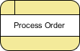

**Data Store**

A data store represents the storage of persistent data required and/or produced by the process. Here are some examples of data stores: membership forms, database table, etc.   
Description: notation (data store)

**Data Flow**

A data flow represents the flow of information, with its direction represented by an arrow head that shows at the end(s) of flow connector.   
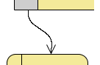

**TYPES OF DFD:**

1. Physical DFD
2. Logical DFD

**PHYSICAL DFD VS. LOGICAL DFD :**

To understand the differences between a physical and logical DFD, we need to know what DFD is. A DFD stands for data flow diagram and it helps in representing graphically the flow of data in an organization, particularly its information system. A DFD enables a user to know where information comes in, where it goes inside the organization and how it finally leaves the organization. DFD does give information about whether the processing of information takes place sequentially or if it is processed in a parallel fashion. There are two types of DFD’s known as physical and logical DFD. Though both serve the same purpose of representing data flow, there are some differences between the two that will be discussed in this article.

Any DFD begins with an overview DFD that describes in a nutshell the system to be designed. A logical data flow diagram, as the name indicates concentrates on the business and tells about the events that take place in a business and the data generated from each such event. A physical DFD, on the other hand is more concerned with how the flow of information is to be represented. It is a usual practice to use DFD’s for representation of logical data flow and processing of data. However, it is prudent to evolve a logical DFD after first developing a physical DFD that reflects all the persons in the organization performing various operations and how data flows between all these persons.

What is the difference between Physical DFD and Logical DFD?

While there is no restraint on the developer to depict how the system is constructed in the case of logical DFD, it is necessary to show how the system has been constructed. There are certain features of logical DFD that make it popular among organizations. A logical DFD makes it easier to communicate for the employees of an organization, leads to more stable systems, allows for better understanding of the system by analysts, is flexible and easy to maintain, and allows the user to remove redundancies easily. On the other hand, a physical DFD is clear on division between manual and automated processes, gives detailed description of processes, identifies temporary data stores, and adds more controls to make the system more efficient and simple.

**Zero-Level DFD:**

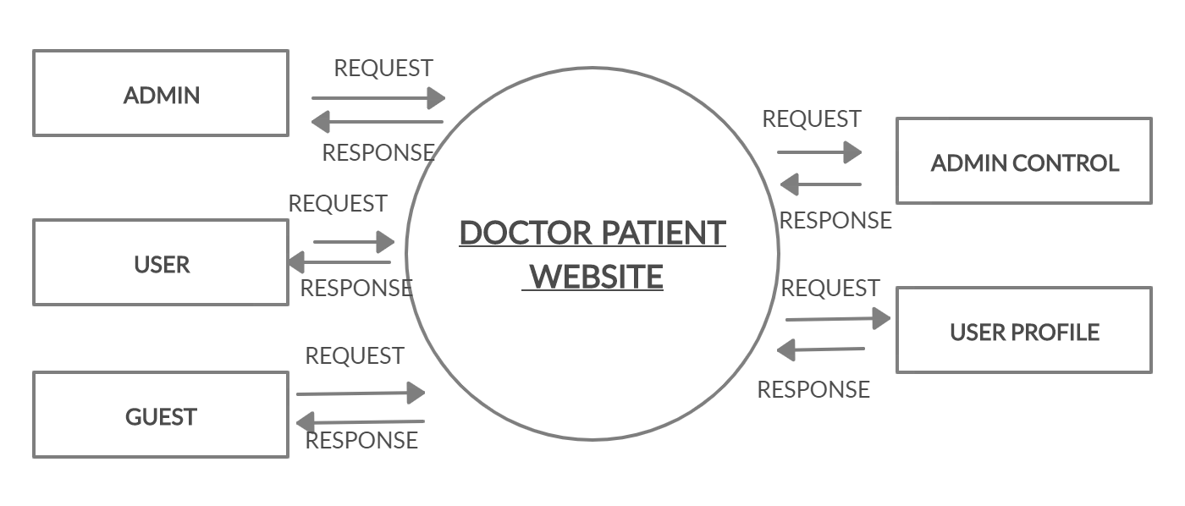

**ER DIAGRAM:**

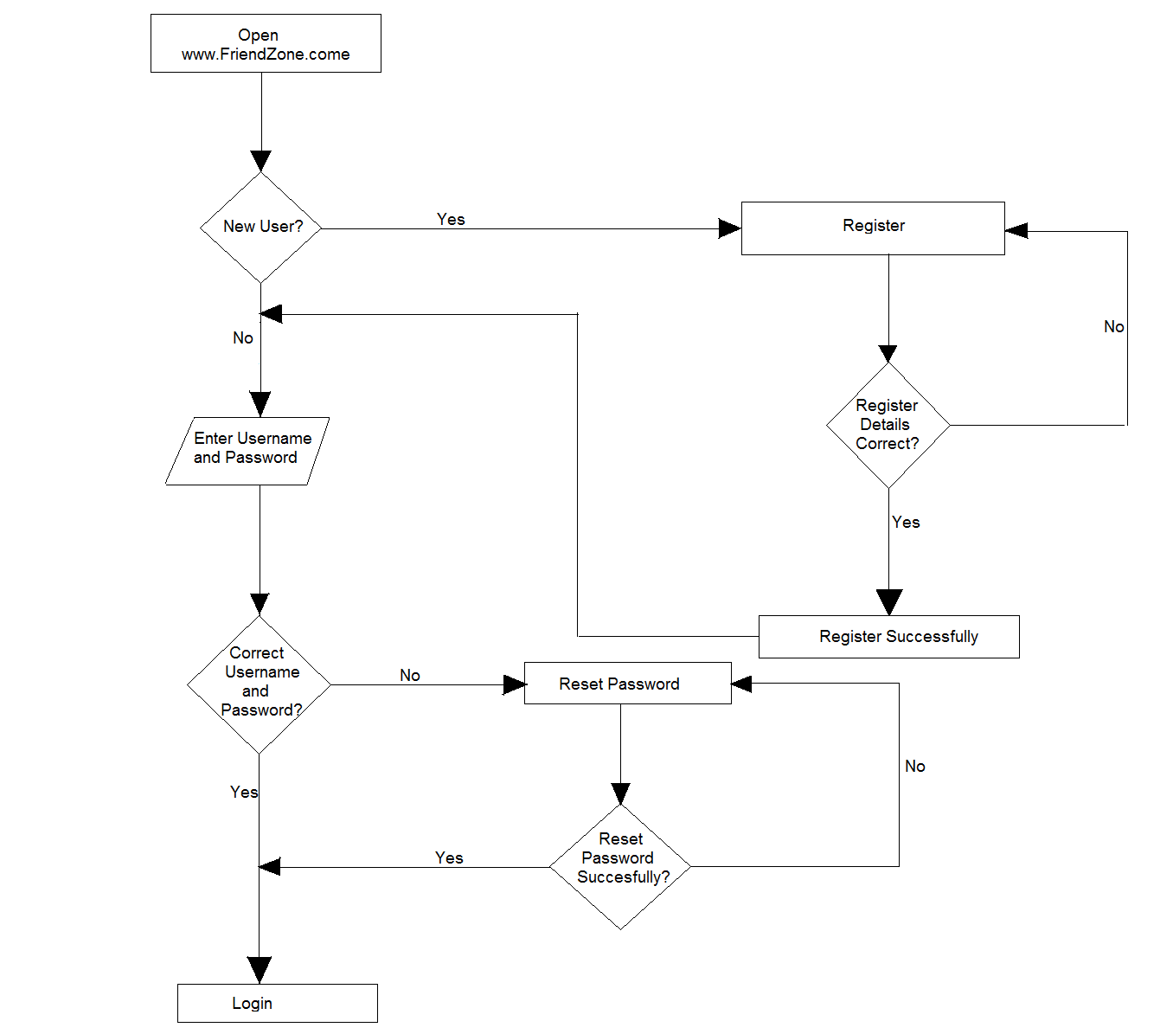

**CHAPTER-6**

**CONCLUSION:**

While developing the system a conscious effort has been made to create and develop a software package, making use of available tools, techniques and resources – that would generate a proper system. While making the system, an eye has been kept on making it as user-friendly. As such one may hope that the system will be acceptable to any user and will adequately meet his/her needs. As in case of any system development process where there are a number of short comings, there have been some shortcomings in the development of this system also. There are some of the areas of improvement which couldn’t be implemented due to time constraints.

**BIBLIOGRAPHY:**

* <https://www.usf.edu/ucm/marketing/intro-social-media.aspx>
* <https://www.easymedia.in/social-media-main-features/amp/>
* [www.usf.edu/ucm/marketing/intro-social-media.aspx](https://www.usf.edu/ucm/marketing/intro-social-media.aspx)
* [www.easymedia.in/social-media-main-features/amp/](https://www.easymedia.in/social-media-main-features/amp/)
* [www.en.m.wikipedia.org](http://www.en.m.wikipedia.org)
* [www.geeksforgeeks.org/css-introduction/](https://www.geeksforgeeks.org/css-introduction/)
* [www.w3schools.com](https://www.w3schools.com)
* [www.quackit.com/tutorial/](https://www.quackit.com/tutorial/)
* [www.tutorialrepublic.com](https://www.tutorialrepublic.com)
* [www.guuru99.com](http://www.guuru99.com)
* [www.javascript.info](http://www.javascript.info)
* [www.developer.mozilla.org](http://www.developer.mozilla.org)
* [www.javatpoint.com/python-tutorial](http://www.javatpoint.com/python-tutorial)
* [www.djangostars.com/blog/why-we-use-django-framework/](http://www.djangostars.com/blog/why-we-use-django-framework/)